Test Case: tc001_SPX_Dev5_Crear_Solicitud_Articulo_Almacen
Step 1 - Enter username and password and click to button Enter : Credentials Entered
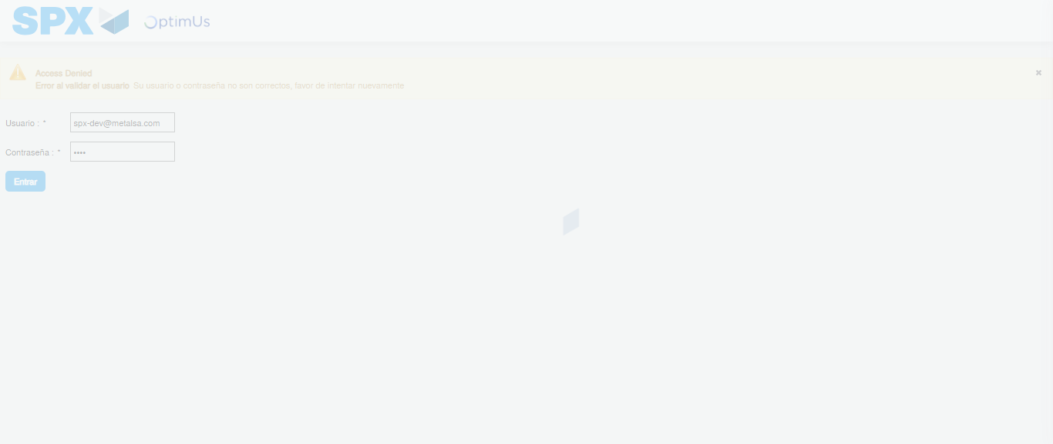Image file-name: QC_Testing-tc001_SPX_Dev5_Crear_Solicitud_Articulo_Almacen-1787940713513

Step 2 - Select to UEN and Access to Request for a New Inventory Item : UEN Correctly selected and Correct access
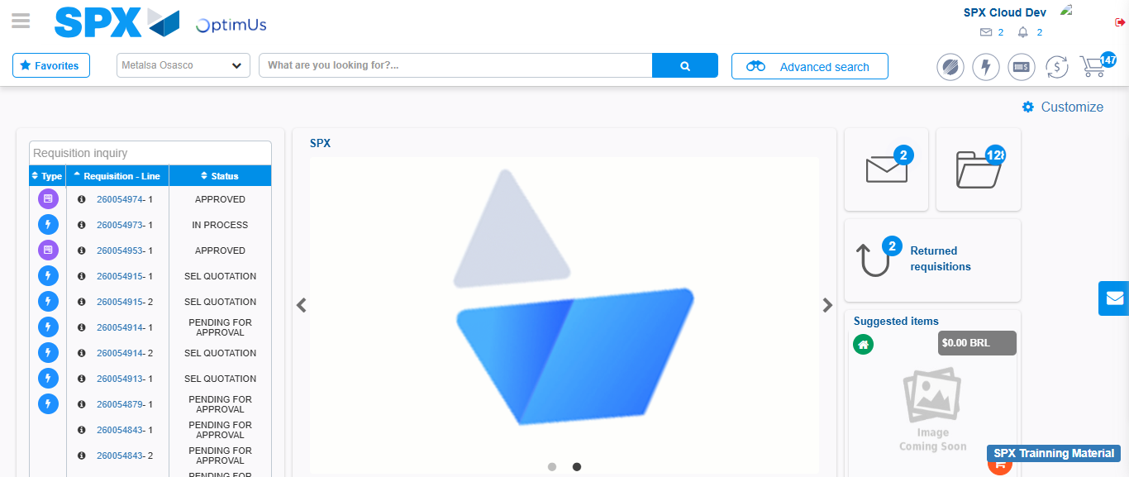Image file-name: QC_Testing-tc001_SPX_Dev5_Crear_Solicitud_Articulo_Almacen-1787940740852

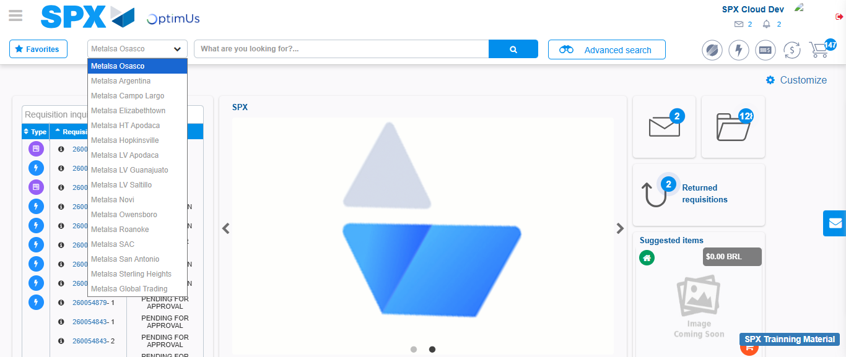Image file-name: QC_Testing-tc001_SPX_Dev5_Crear_Solicitud_Articulo_Almacen-1787940741327

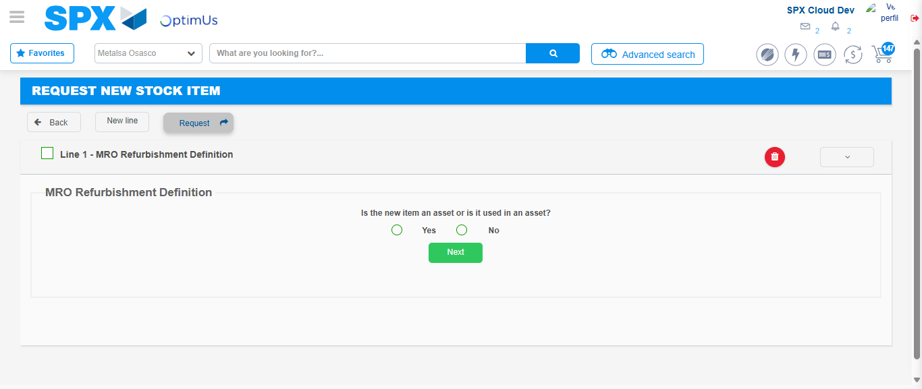Image file-name: QC_Testing-tc001_SPX_Dev5_Crear_Solicitud_Articulo_Almacen-1787940778015

Step 3 - Select options first section : Options seleted correctly
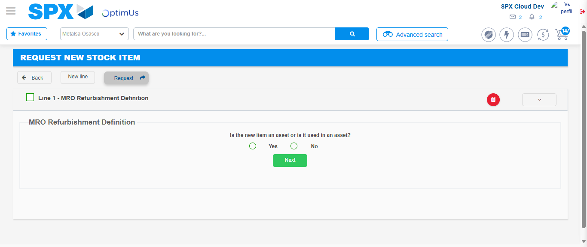Image file-name: QC_Testing-tc001_SPX_Dev5_Crear_Solicitud_Articulo_Almacen-1787940778297

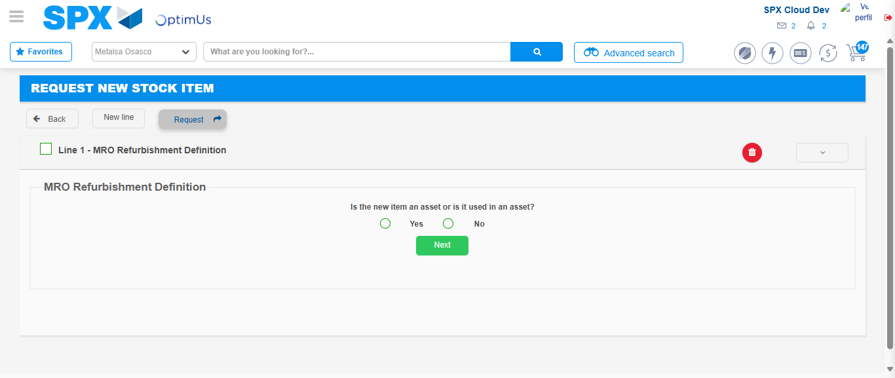Image file-name: QC_Testing-tc001_SPX_Dev5_Crear_Solicitud_Articulo_Almacen-1787940778517

Step 4 - Select options at Screen: Options seleted correctly
Image file-name: QC_Testing-tc001_SPX_Dev5_Crear_Solicitud_Articulo_Almacen-1787940778297

Image file-name: QC_Testing-tc001_SPX_Dev5_Crear_Solicitud_Articulo_Almacen-1787940778517

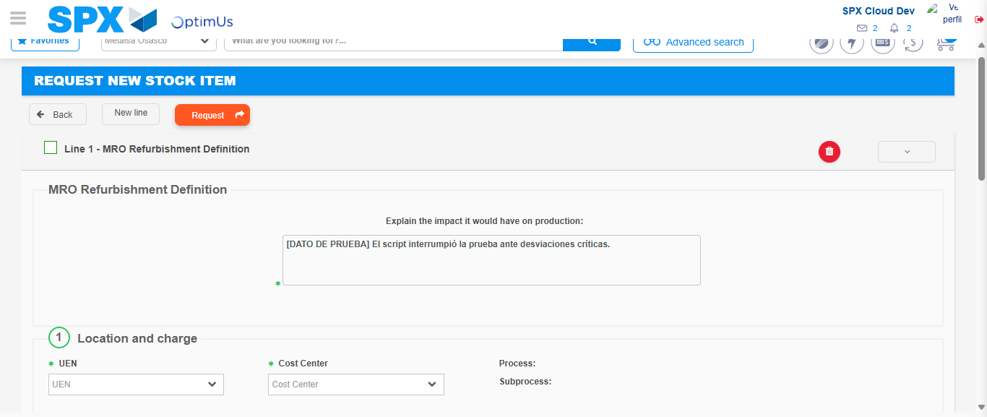Image file-name: QC_Testing-tc001_SPX_Dev5_Crear_Solicitud_Articulo_Almacen-1787940788333

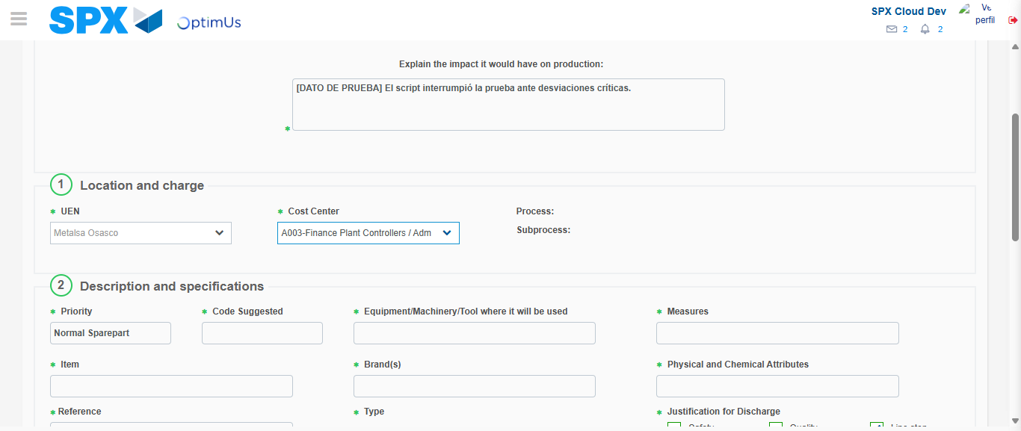Image file-name: QC_Testing-tc001_SPX_Dev5_Crear_Solicitud_Articulo_Almacen-1787940790751

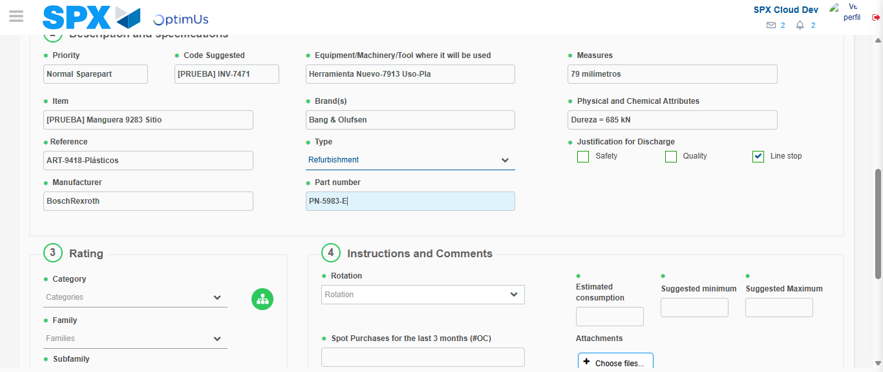Image file-name: QC_Testing-tc001_SPX_Dev5_Crear_Solicitud_Articulo_Almacen-1787940792045

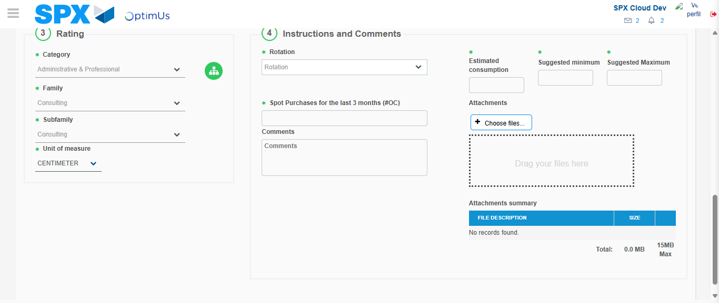Image file-name: QC_Testing-tc001_SPX_Dev5_Crear_Solicitud_Articulo_Almacen-1787940796251

Step 5 - Request New Item : Request Accepted
Image file-name: QC_Testing-tc001_SPX_Dev5_Crear_Solicitud_Articulo_Almacen-1787940740852

Image file-name: QC_Testing-tc001_SPX_Dev5_Crear_Solicitud_Articulo_Almacen-1787940741327

Image file-name: QC_Testing-tc001_SPX_Dev5_Crear_Solicitud_Articulo_Almacen-1787940778015

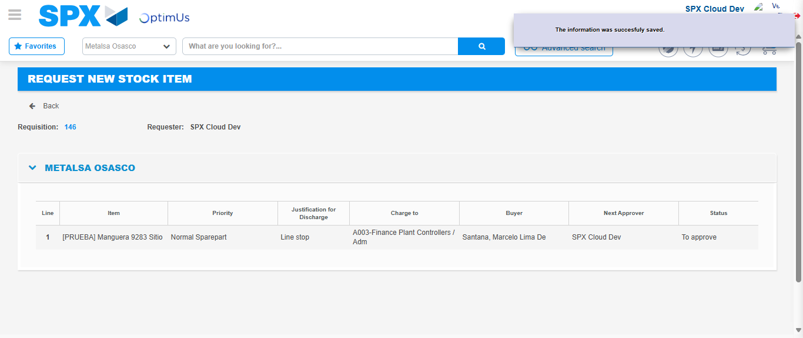Image file-name: QC_Testing-tc001_SPX_Dev5_Crear_Solicitud_Articulo_Almacen-1787940803311

Image file-name: QC_Testing-tc001_SPX_Dev5_Crear_Solicitud_Articulo_Almacen-1787940803487

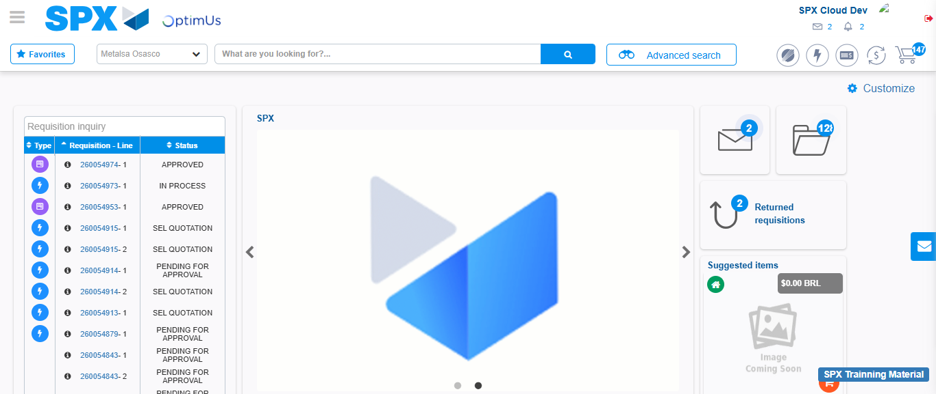Image file-name: QC_Testing-tc001_SPX_Dev5_Crear_Solicitud_Articulo_Almacen-1787940824605

Step 7 - Return to Main Page SPX : Return to Main Page SPX
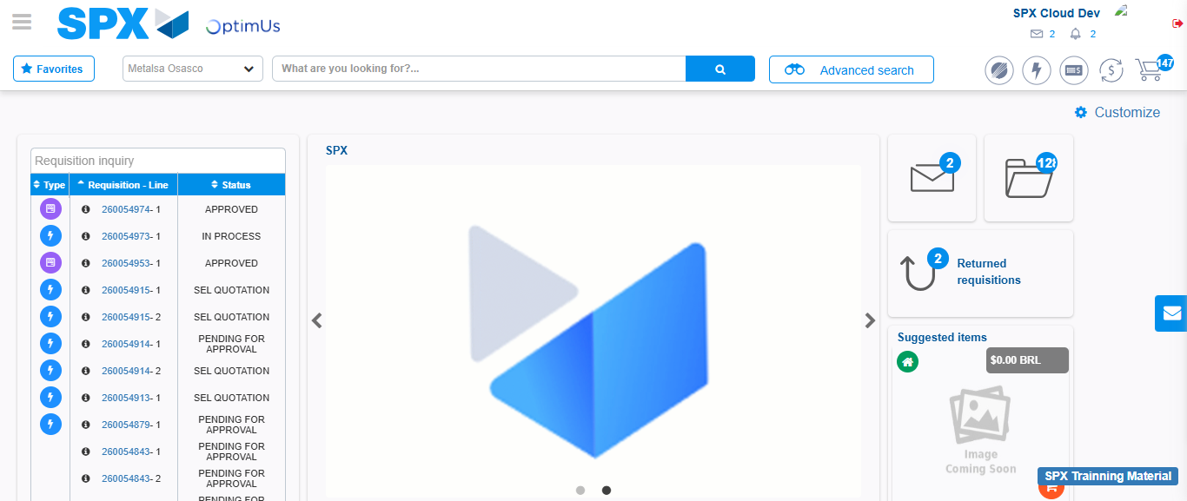Image file-name: QC_Testing-tc001_SPX_Dev5_Crear_Solicitud_Articulo_Almacen-1787940824865

